Active Directory

- Active Directory:is bascially a company master list of people,computers, one server contols everything all devices, Pcs within the server without Active Directory: Every PC has its own users, Every password is managed separately.Every permission is managed separately.It manages and controls all pcs within the server. Example
- Domain:A centrally managed network containing users, computers and resources.Its the school
- OU:Organisational unit a container in Active Directory used to organise users and computers.the classroom
- Group:A collection of users used to manage permissions efficiently.the students the teamll
Active Directory Server

├─ David
├─ Sarah
├─ John
├─ Emma
│
├─ Laptop-001
├─ Laptop-002
├─ Laptop-003
│
├─ IT Group
├─ Sales Group
├─ HR Group

David Smith
Username: dsmith
Password: ********
Department: IT

Now you can:
- Log into your laptop.
- Access company files.
- Use Outlook.
- Use Teams.
- Access printers.

With AD you can
- Create user
- Disable user
- Reset password
- Unlock account
- Add user to group

- Windows virtual server (virtualbox)
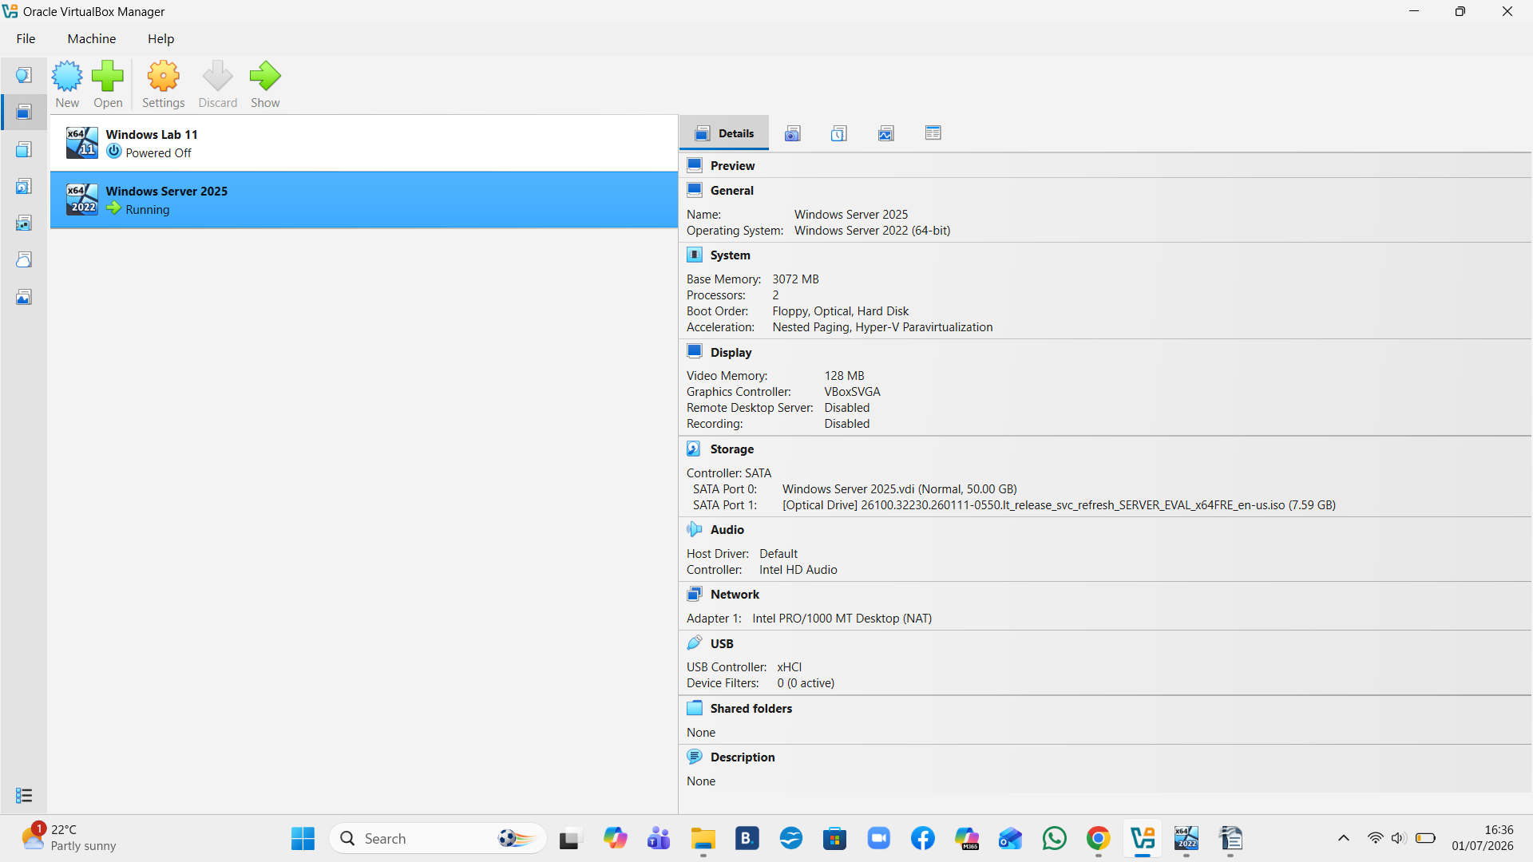
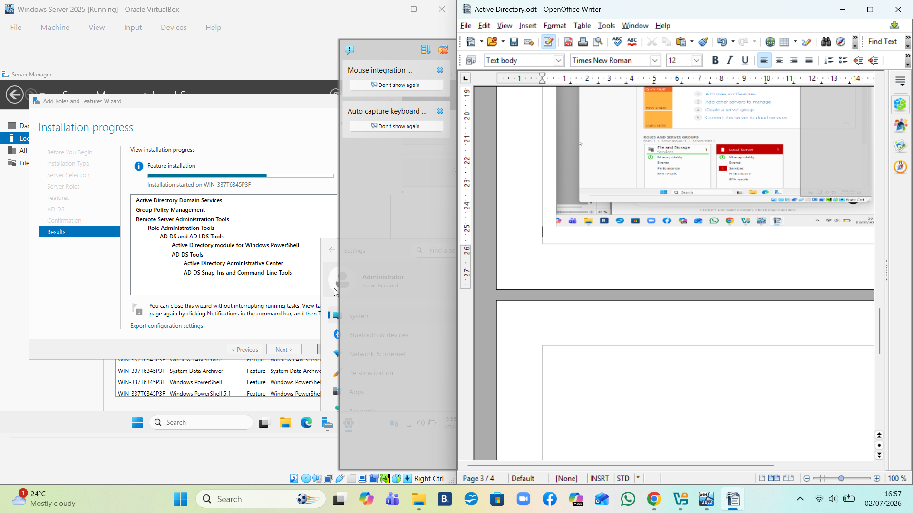

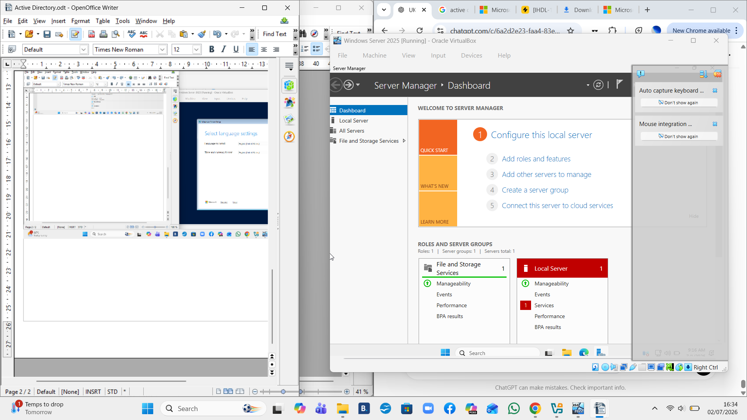

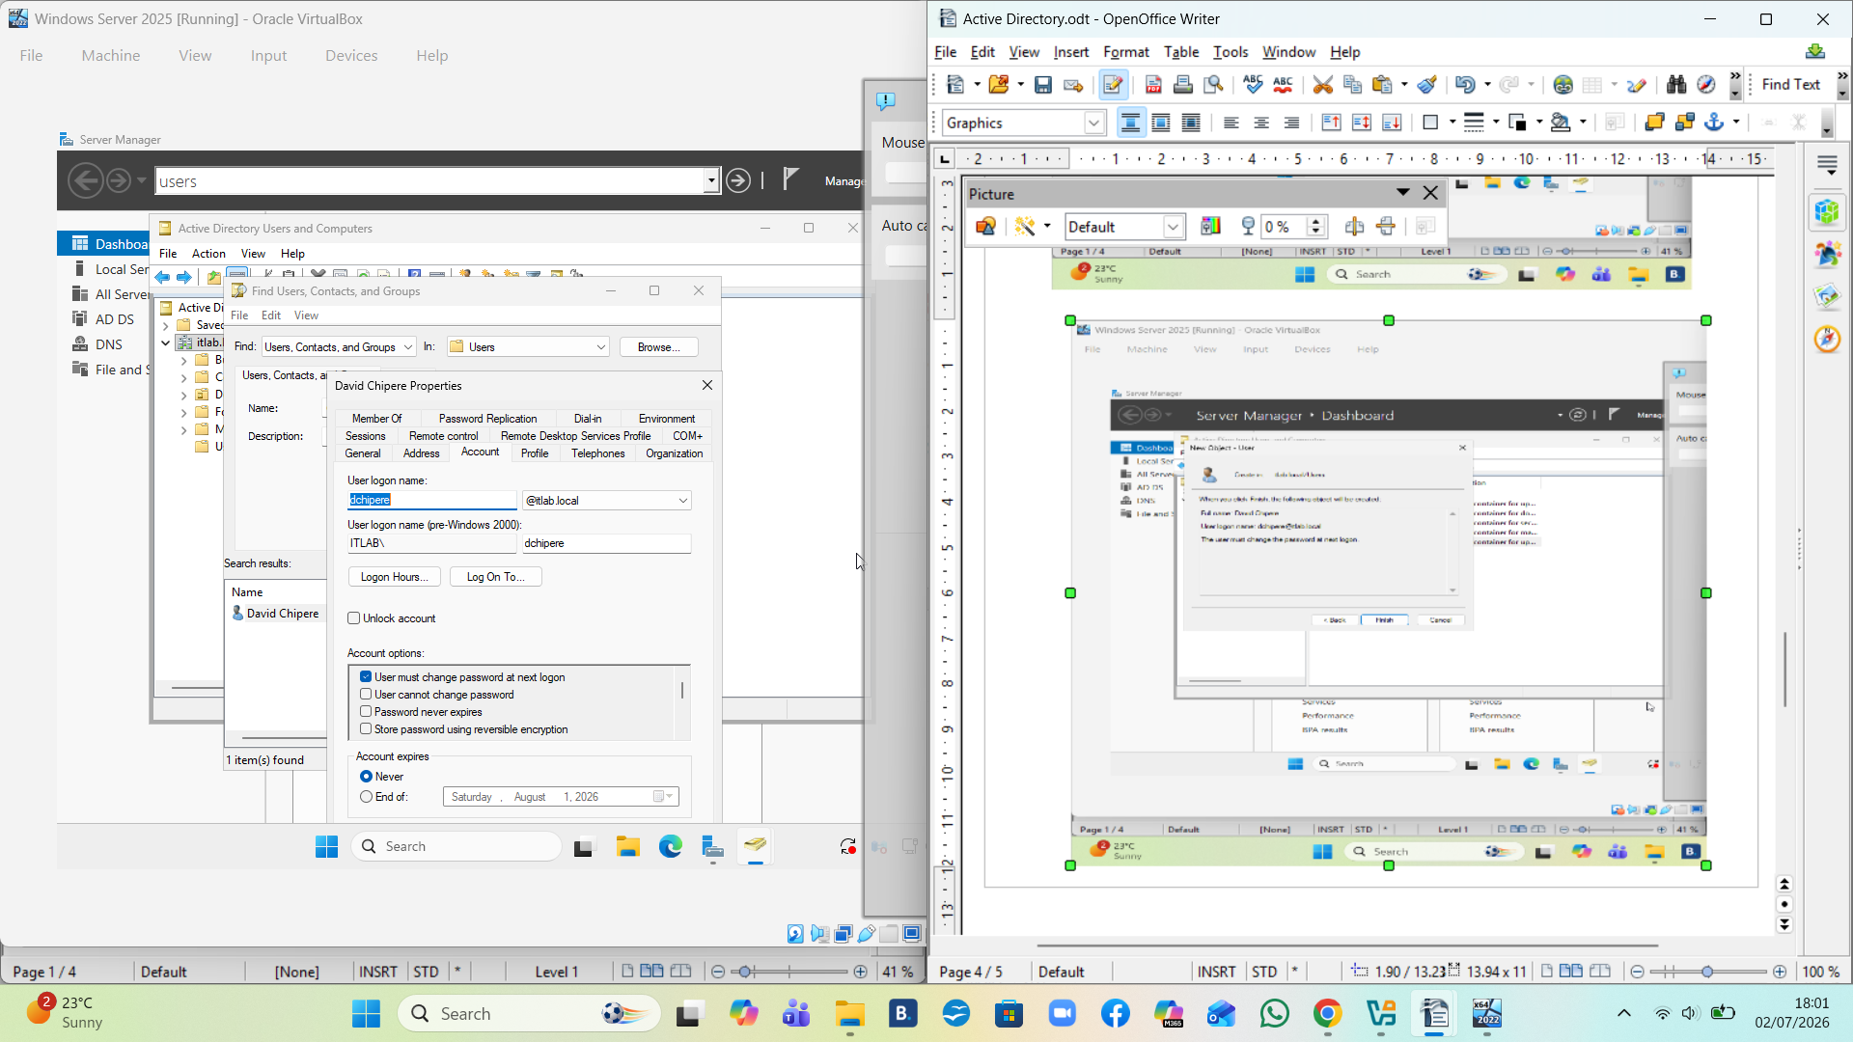

dllll

